DAY 4 - Assignment 1 MRIGANKA PATRA
Emp ID: 2415820
Email: mriganka.patra@cognizant.com

Tasks:
1. Define the Defect Life Cycle and illustrate its stages.
In a software development process, the bug has a life cycle. The bug should go through the life cycle to be closed. A specific life cycle ensures that the process is standardized. The bug attains different stages in the life cycle. It is as follows,
- New vs. Open:
  - When a defect is first identified by the tester, the initial status is set to "New".
  - Once the developer accepts the defect, the status is changed to "Open" to indicate that the defect is being addressed.
- Assigned
  - The defect is assigned to a developer (or a relevant team member) for analysis and fixing.
- Reopen and Closed:
  - After the developer fixes the defect, the tester verifies the fix in the next build.
  - If the fix is successful, the tester sets the status to "Closed".
  - If the fix is not successful, the tester sets the status back to "Reopen" for further investigation and rectification.
- Fixed for Verification, Fixed, and Rectified:
  - When the developer fixes a defect, the status is set to "Fixed for Verification" to indicate that the fix is ready for testing.
  - Once the tester verifies the fix, the status is updated to "Fixed" or "Rectified" to confirm the successful resolution of the defect.
- Hold:
  - The "Hold" status is used when the developer is unsure whether to accept or reject the reported defect.
  - This allows for further investigation and decision-making before proceeding with the defect resolution process.
- Testers Mistake/Error, Rejected:
  - If the developer determines that the reported defect is not a genuine issue, they can set the status to "Testers Mistake/Error" or "Rejected".
  - This indicates that the reported defect is not a valid defect and does not require further action.
- As Per Design:
  - In rare cases, the developer may determine that the reported issue is not a defect but rather a feature that aligns with the design specifications.
  - In such cases, the developer can set the status to "As Per Design" to indicate that the behavior is intentional and not a defect.
- Reopen
If during retesting the defect is still reproducible (fix is unsuccessful), it is moved back to Reopen, and the cycle continues.
- Rejected / Invalid
The defect is not valid — either it is not reproducible, is by design, or is a duplicate — it is marked Rejected.
2. Create a diagram or flow chart of the defect life cycle.
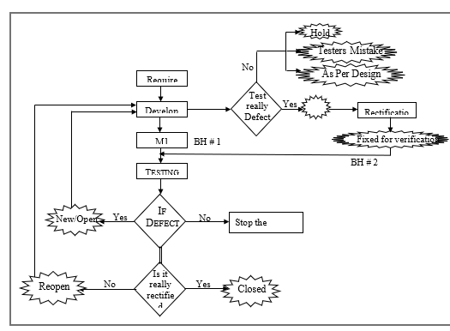

3. List the essential fields required when logging a defect in a tracking tool.
Field | Purpose
Defect ID (auto-generated) | Unique identifier for the defect
Title / Summary | Short, clear description of the defect
Description | Detailed explanation of the defect, including how to reproduce it
Steps to Reproduce | Precise steps the tester followed to encounter the defect
Expected Result | What the system was expected to do
Actual Result | What the system actually did
Severity | Impact of the defect on the system (e.g., Critical, Major, Minor)
Priority | Business urgency of fixing the defect (e.g., High, Medium, Low)
Environment | System/OS/browser version where the defect was found
Version / Build | Software version/build number where the defect was detected
Attachments | Screenshots, logs, videos to help developers understand the defect
Assigned To | Developer or team responsible for resolving the defect
Status | Current status (e.g., New, In Progress, Fixed, Reopened, Closed)
Reporter | Person who reported the defect
Date Created / Modified | Date/time of defect creation and updates

4. Describe the importance of peer reviews in the defect prevention process.
Peer Review: A process where team members review each other’s work (code, design, test cases) before it is integrated.

Importance:
- Early Detection of Defects:
  - Helps catch defects early in the development cycle, before they reach testing or production.
- Knowledge Sharing:
  - Promotes understanding of code, design, and standards across the team.
- Improved Code Quality:
  - Ensures adherence to coding best practices and architectural guidelines.
- Reduced Rework:
  - Early identification and correction of issues save time and effort during later stages.
- Team Collaboration:
  - Encourages collaborative ownership of code and better team cohesion.
- Defect Prevention:
  - By identifying potential design flaws, logic errors, and poor practices before code execution, peer reviews act as a first line of defense against defects.
5. Choose a bug tracking tool (e.g., Jira, Bugzilla) and simulate the lifecycle of a sample defect.
Sample Defect: Submit button does not respond on Checkout page.
Lifecycle Simulation:
Stage | Action
New / Open | QA tester discovers that clicking the Submit button on the Checkout page has no effect. Logs a defect in Jira with severity Critical and priority High.
Assigned | The defect is assigned to a frontend developer for investigation.
In Progress | Developer analyzes the defect, finds a missing event listener in the JavaScript code. Starts fixing the issue.
Resolved / Fixed | Developer commits the fix, updates Jira status to Resolved, and tags the defect with the fixed version. Adds notes about the root cause.
Ready for Retest | QA tester retests the Checkout page on the updated build.
Closed | QA verifies that the Submit button works as expected. Updates the defect status to Closed.
Reopened (optional) | If the issue persists or recurs, QA can reopen the defect for further investigation.

